Paper Boat work with local experts and grassroots community-based partners in hard to reach communities. At the core of what we do are creative learning spaces called Children’s Hubs.  The photo and words on the front are by Dhanabalakumar, a boy from a marginalized community in rural Kovilpatti, Tamil Nadu, India. At children’s hubs, children like Dhanabalakumar find both their voices and the wind in the sails to take their dreams beyond the horizon.  A gift to Paper Boat is a gift that can help a child’s dream take flight, as together, we can inspire and enable them to sail beyond the horizon…towards a world that unlocks the infinite potential of every child.  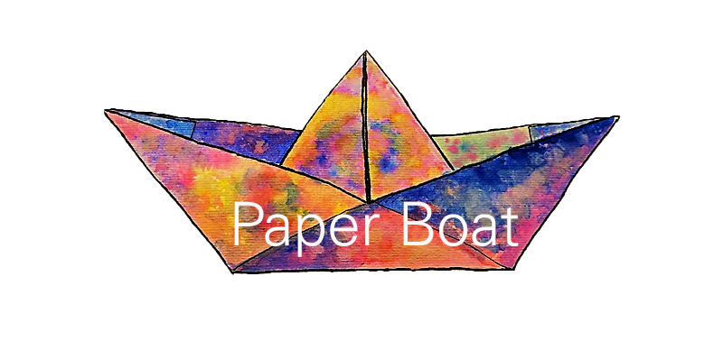  Paperboatcharity.org.uk | 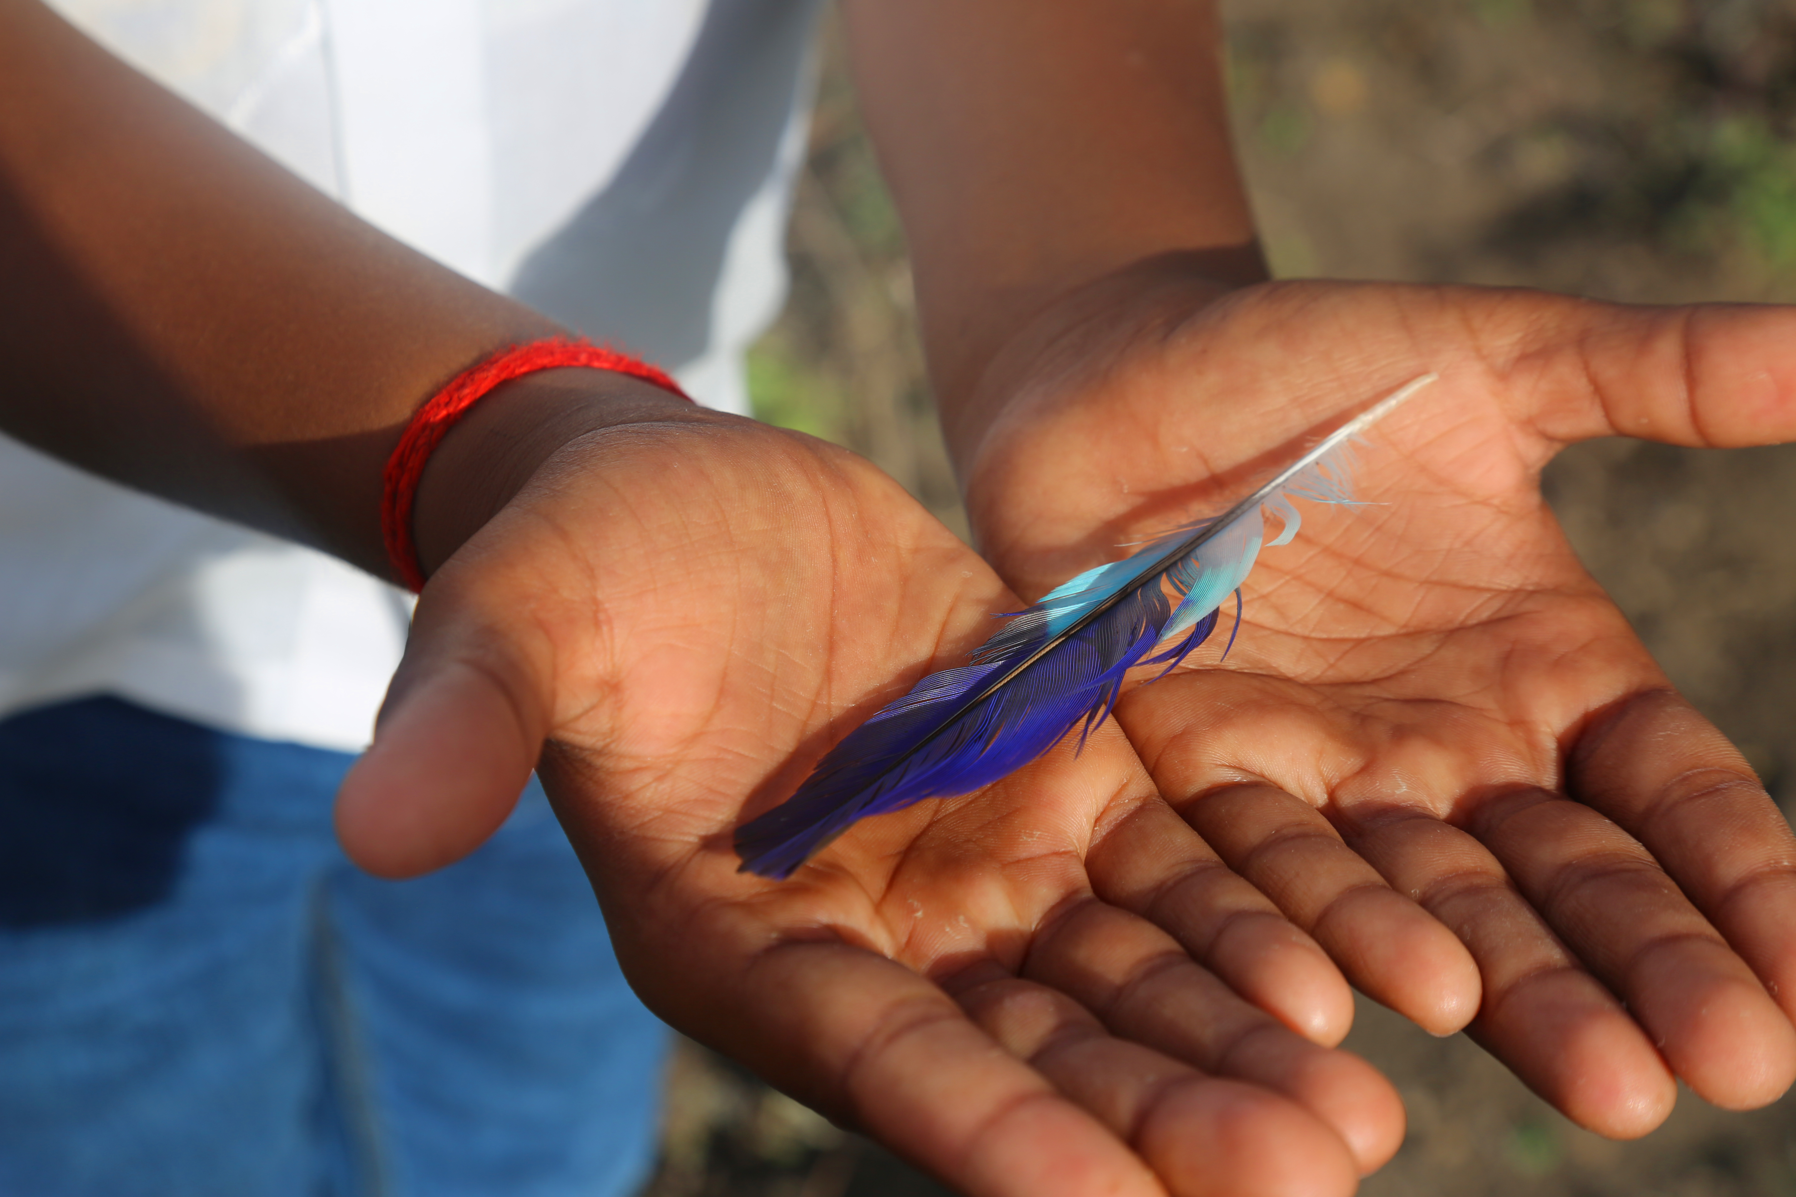  “I saw a feather of a beautiful bird falling down. I made someone hold it for me. Now these hands look more tender than the feather.”  A gift that can unlock infinite potential
Paper Boat work with local experts and grassroots community-based partners in hard to reach communities. At the core of what we do are creative learning spaces called Children’s Hubs.  The photo and words on the front are by Dhanabalakumar, a boy from a marginalized community in rural Kovilpatti, Tamil Nadu, India. At children’s hubs, children like Dhanabalakumar find both their voices and the wind in the sails to take their dreams beyond the horizon.  A gift to Paper Boat is a gift that can help a child’s dream take flight, as together, we can inspire and enable them to sail beyond the horizon… towards a world that unlocks the infinite potential of every child.  Paperboatcharity.org.uk | “I saw a feather of a beautiful bird falling down. I made someone hold it for me. Now these hands look more tender than the feather.”  A gift that can unlock infinite potential
In the spirit of the holiday season, I've made a donation to Paper Boat in your name to honour your generous nature.
மகிழ்ச்சியான விடுமுறை நாட்கள்
Happy Holidays!

In the spirit of the holiday season, I've made a donation in your name to honour your generous nature.
மகிழ்ச்சியான விடுமுறை நாட்கள்
Happy Holidays!

.

